New section on my account called “My Document”.
Set this in “Settings” section, and inside under “Profile Information”

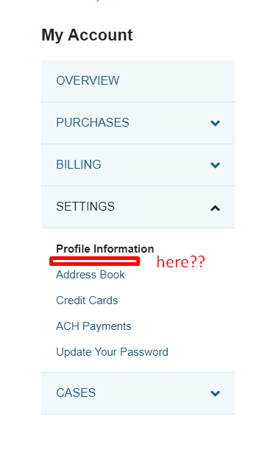

- Instructions Text Box: text for instructions on how to upload their Tax Exemption Certificate
  - Customer wants to add an instruction text field on this page. Section will be located towards the top of the page, suggestion below taken from a customization Pablo did for Trace3:
  - 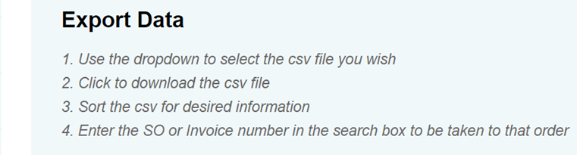
    - In example above Export Data is the page name in the same manner as all other My Account pages.
    - The text below is managed via Translations. For this page I would request the block of text be My_Documents_Instruction_Box (Field from configuration.json?)
    - Client will manage creating and managing this text box going forward.
- Client wants the file deposited into the customer record, under files as shown in the screenshot below:
  - 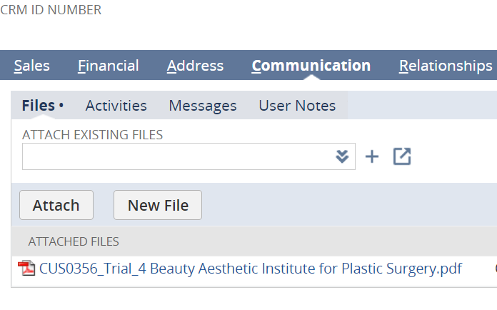
  - Customer is aware and accepting that they will be responsible for managing and removing files as needed to prevent them running out of space in the file cabinet.

20hs
Use the reusable solution:
https://csnetsuite.custhelp.com/app/answers/answer_view/a_id/1007853/loc/en_US
Everything is there.

Some notes
Puedo instalar el bundle, y de ahí descargar la extension y modificarla, para hacerla 2.0.
Sino, en mi caso yo cree la mía, y tengo que hacer los pasos que me dice la solución reusable, mas agregar un permiso al rol creado:
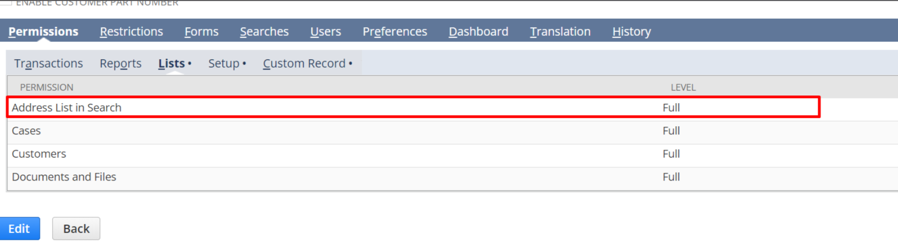
La carpeta de live hosting files no le puedo tirar derecho el file, tengo que poner un permiso en el rol.

Y agregarle al modelo:
record.attach({
record: {
type: 'file',
id: fileId
},
to: {
type: 'customer',
id: runtime.getCurrentUser().id
}
});

